Challenge:

Babe RE

# Challenge Description:

Show us your basic skills! (P.S. There are 4 ways to solve this, are you willing to try them all?)

# Context:

## Basically get the Key / Passcode for the application to get the flag.

# Notes:

* Just use ltrace to do this challenge

# Flag:

* First, download the application and run it.
* After Running the application it will ask for a key that we don't know, after running we ltrace we know it wants a key that's 13 Chars long (the actual key is 11 characters long its 13 because of formatting a new line in the actual code of the application eg ‘’\N’’),
* After pressing enter a key is shown due to ltrace being run with it, we run the program again after exit, and input the key it printed out to get the key and bamm Flag.

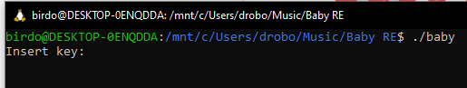

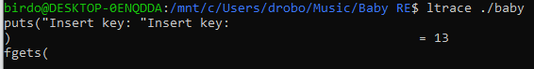

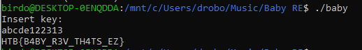

We get the flag : HTB{B4BY_R3V_TH4TS_EZ}

From Birdo